**Front-End UI/UX Development**    
   
   
**Front-End UI/UX Development Mini Project**    
   
   
**UI/UX DESIGN FUNDAMENTALS**

**Submitted by:**

|  |  |  |  |  |
| --- | --- | --- | --- | --- |
| **SR.NO** | **NAME** | **REGISTER**  **NUMBER** | **COLLEGE EMAIL ID** | **CLASS** |
| 1. | JEROLIN MATHEW | 2462331 | jerolin.mathew@btech.christuniversity.in | 3BTCS DS |
| 2. | ADWAITH PRAVEEN | 2462308 | adwaith.praveen@btech.christuniversity.in | 3BTCS DS |
| 3. | PRASANNA R.D | 2462349 | prasanna.rd@btech.christuniversity.in | 3BTCS DS |

**Instructor Name**: Mrs. Nagaveena

**Institution Name:** Christ (Deemed to be University), Bangalore

**Date of Submission:**12/08/2025

**RESTAURANT LANDING PAGE**

**1.Abstract**

This project focuses on designing and developing a visually appealing and fully responsive landing page for a restaurant named *Delicious Bites*. Built using HTML5 and CSS3, the landing page highlights the restaurant’s branding, menu offerings, and contact information. The primary goal was to create a user-friendly interface that works seamlessly across devices, using only front-end technologies without any JavaScript or backend integration. Core technologies include semantic HTML5, CSS3, Flexbox, CSS Grid, and media queries. The final outcome is a clean, professional landing page that provides an engaging user experience and effectively communicates the restaurant’s identity.

**2.Objectives**

* Design a modern, restaurant-themed landing page with an attractive UI.
* Implement a fully responsive layout using only HTML and CSS.
* Use semantic HTML5 elements for structured content.
* Apply Flexbox and CSS Grid for organized layouts.
* Ensure accessibility and readability across mobile, tablet, and desktop.
* Use custom fonts and colors to match restaurant branding.

**3.Scope of The Project**

**Included:**

* Front-end development only (HTML5 + CSS3).
* Fully responsive design for desktop, tablet, and mobile devices.
* Menu section with categories and styled dish cards.
* About and Contact sections for restaurant information.
* Integration of Google Fonts for branding.
* Use of hover effects for interactivity.

Not Included:

* No JavaScript functionality (no menu filters, dynamic content, or animations).
* No backend or database integration.
* No online booking or form submission functionality.
* No third-party frameworks like Bootstrap; only pure HTML and CSS used.

**5. Tools & Technologies Used**

* HTML5 – For structuring the content using semantic tags.
* CSS3 – For styling and layout design.
* Flexbox – For flexible and adaptive layout arrangements.
* CSS Grid – For organizing menu items and content sections.
* Media Queries – For making the design responsive across devices.
* Google Fonts – For custom typography and enhanced visual appeal.
* VS Code – As the code editor for development.
* Web Browser Developer Tools – For testing and debugging layouts.
* Image Optimization Tools – For reducing image size without losing quality.

**6. HTML Structure Overview**

## File: restaurant_landing.html

## <header>: Contains restaurant name/logo and navigation menu.

## <nav>: Navigation links to different sections (Home, Menu, About, Contact).

## <section class="hero">: Hero banner with welcoming text and call-to-action.

## <section class="menu">: Menu categories with food items.

## <section class="about">: About the restaurant’s story.

## <section class="contact">: Contact details, address, and timings.

## <footer>: Copyright and social media links.

## File: restaurant_css.css

## Global styles: Fonts, colors, margins, padding reset.

## Layout: Flexbox for navigation/menu, CSS Grid for menu items.

## Media Queries: For responsiveness on different screen sizes.

## Hover Effects: Scaling, color changes, and transitions.

## Theme Variables: CSS variables for color scheme customization.

## ****7. CSS Styling Strategy****

* External CSS File – All styles are stored in a separate restaurant_css.css file for clean code management.
* Organized with Comments & Sections – CSS divided into logical sections (e.g., Header, Hero, Menu, About, Contact, Footer).
* Flexbox & CSS Grid – Used for layout flexibility and organized content presentation.
* Media Queries – Implemented for mobile-first responsiveness, ensuring the site works well on small screens first.
* CSS Variables – Defined theme colors and font styles at the root level for easy customization.
* Hover Effects & Transitions – Applied to buttons, links, and menu cards for an interactive feel.
* Accessible Fonts & Colors – Chosen for readability and high contrast for better accessibility.

**8. Key Features**

* Responsive Design – Works on all devices.
* Navigation Bar – Fixed top nav with hover effects.
* Menu Section – Grid layout for dishes with hover scaling.
* Hero Section – Eye-catching banner with welcoming text.
* About Section – Brief history and highlights of the restaurant.
* Contact Section – Address, timings, and contact details.
* Custom Typography – Google Fonts for a unique look.

**9. Challenges Faced & Solutions**

| **Challenge** | **Solution** |
| --- | --- |
| * Overlapping elements on smaller screens | * Used media queries to adjust layout and stack elements vertically |
| * Difficulty aligning menu items with floats | * Replaced float with CSS Flexbox and Grid |
| * Fonts looking inconsistent on different browsers | * Used Google Fonts with fallback font families |
| * Large background images affecting load time | * Optimized image size for web without losing |

## ****10. Outcome****

## Achieved a modern and responsive landing page that aligns with the restaurant’s branding.

## Implemented a clean design hierarchy for better user navigation.

## Learned effective use of CSS Grid, Flexbox, and media queries for responsiveness.

## Improved skills in semantic HTML structuring and CSS styling.

## ****11. Future Enhancements****

* Add JavaScript for menu filtering and animations.
* Include an online reservation form with backend integration.
* Add smooth scroll and page transition effects.
* Implement light/dark mode toggle for theme customization.

**12. Screenshots of the Code And Webpage**

Restaurant_landing.html:  
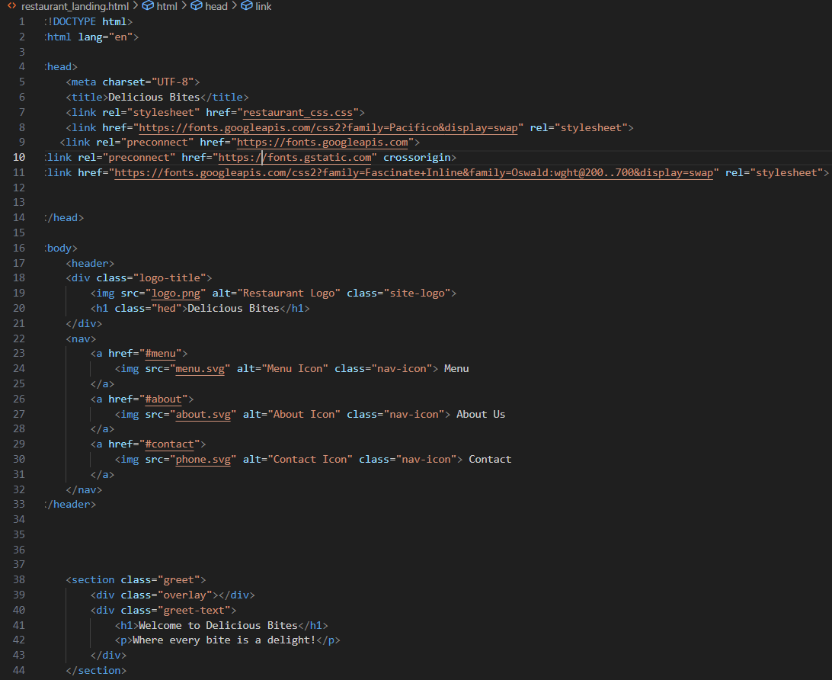

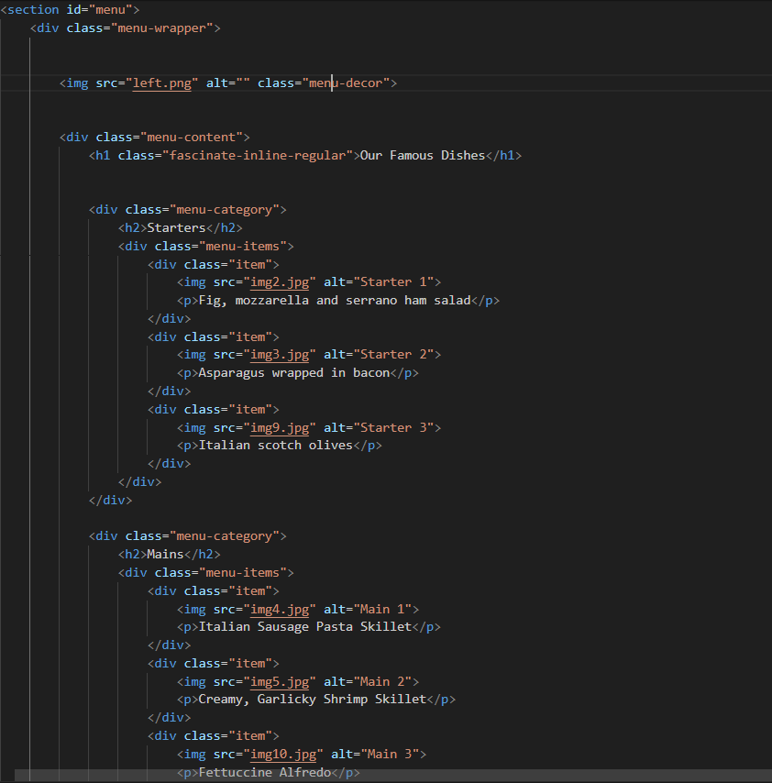

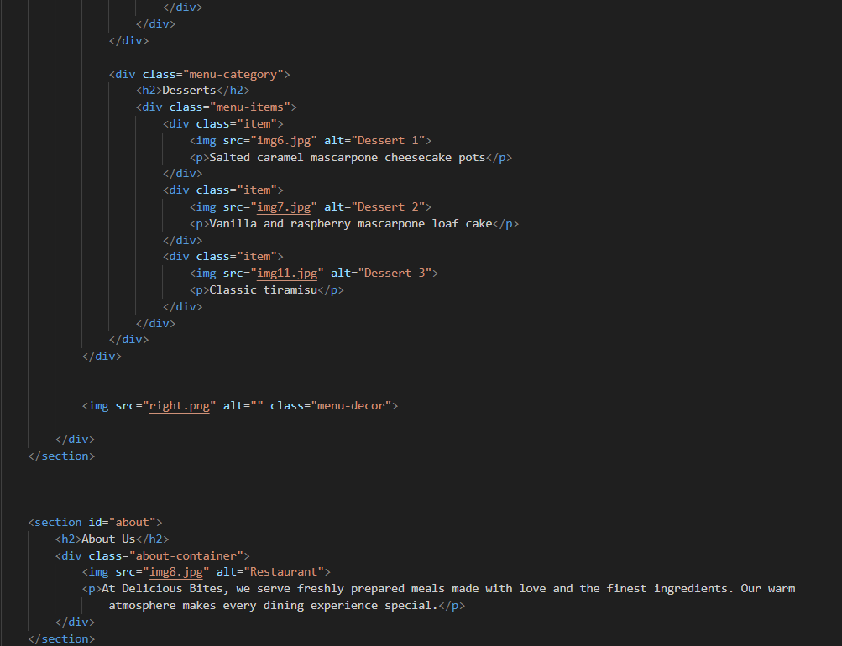

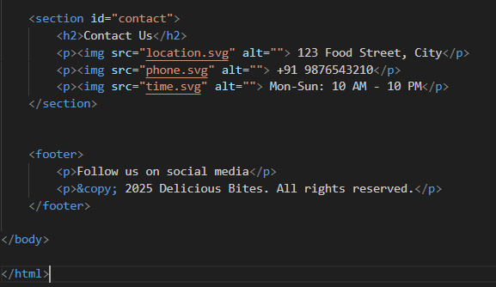

Restaurant_css.css:  
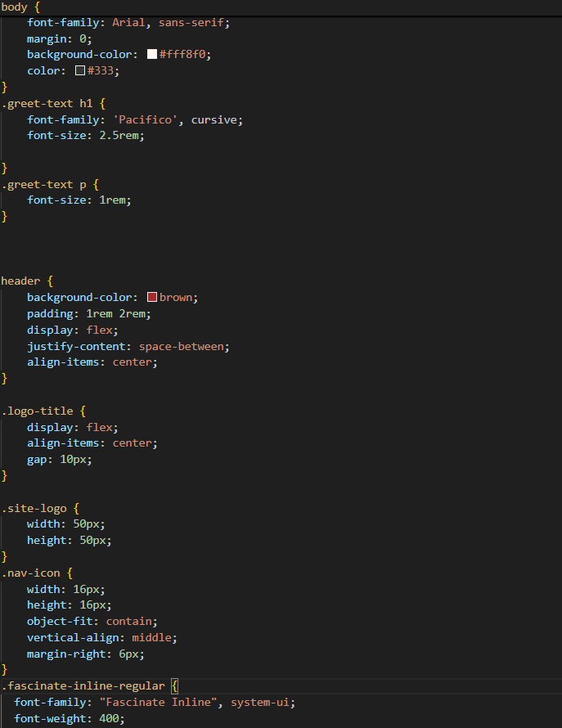

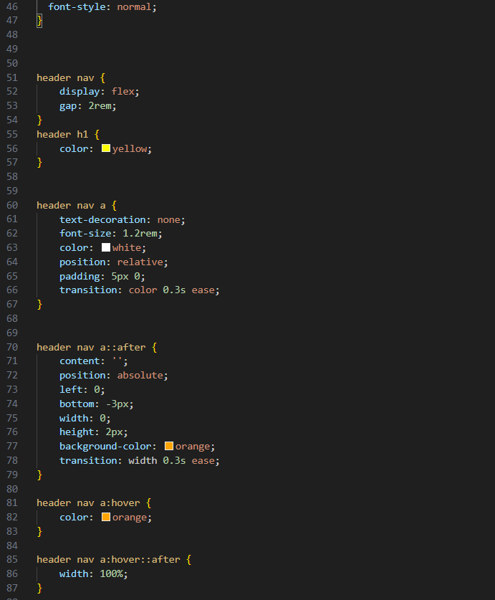

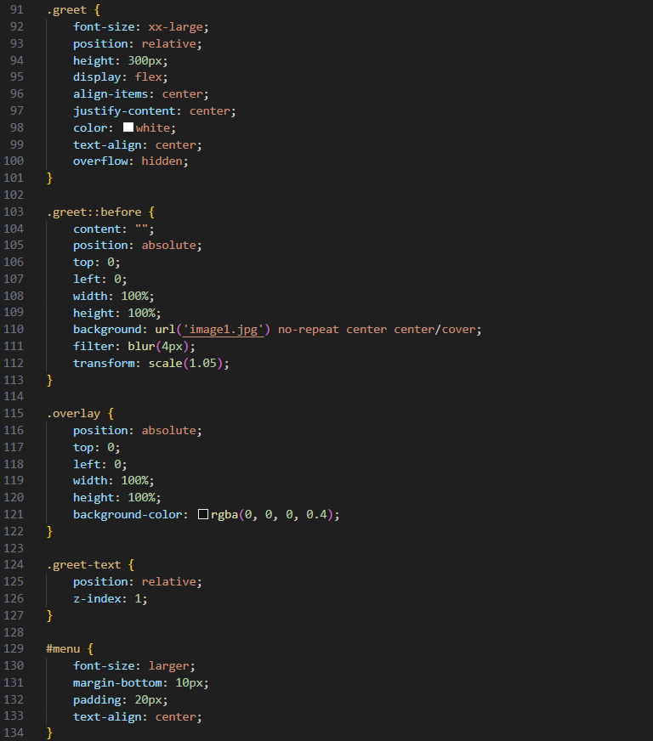

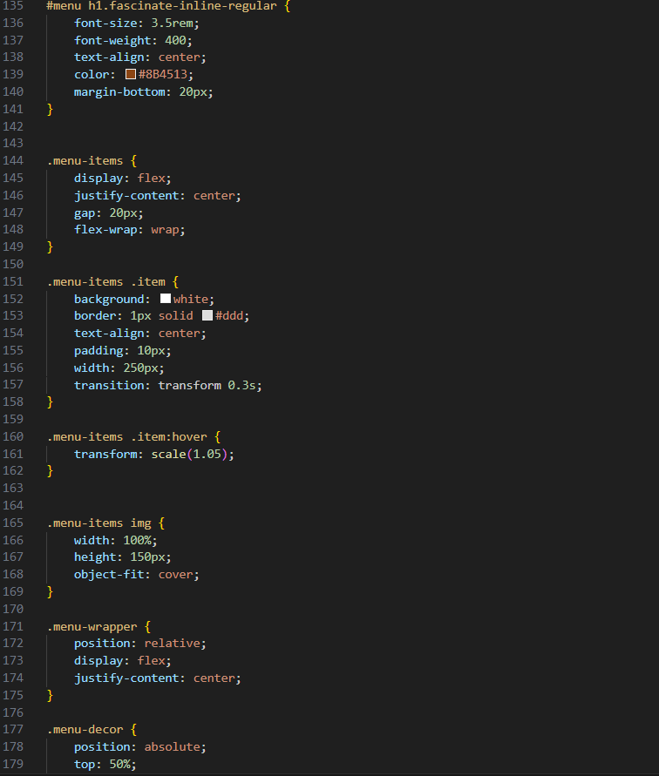

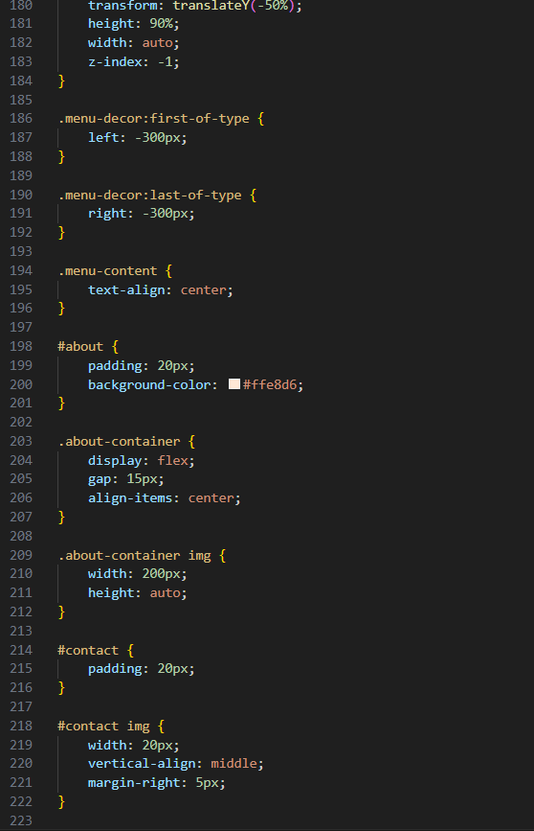

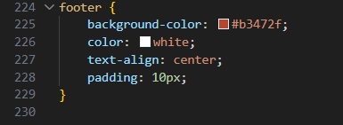

Webpage:

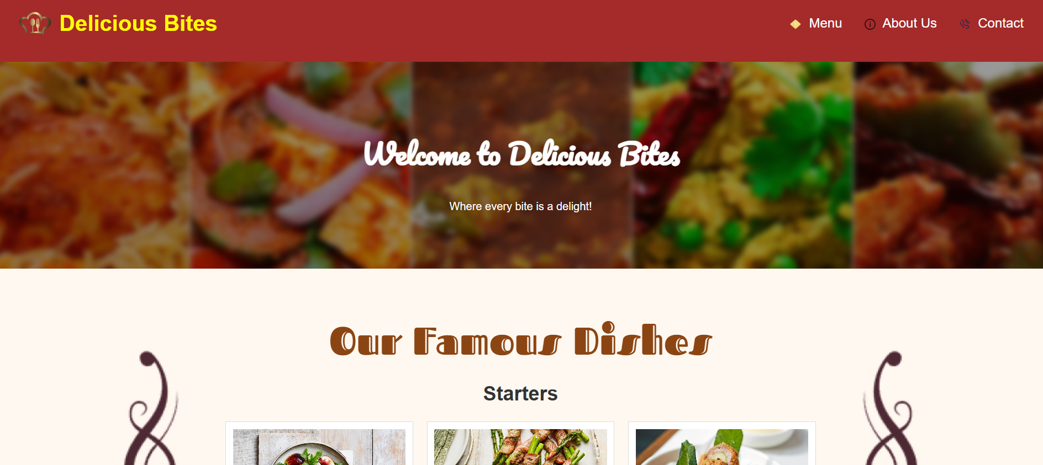

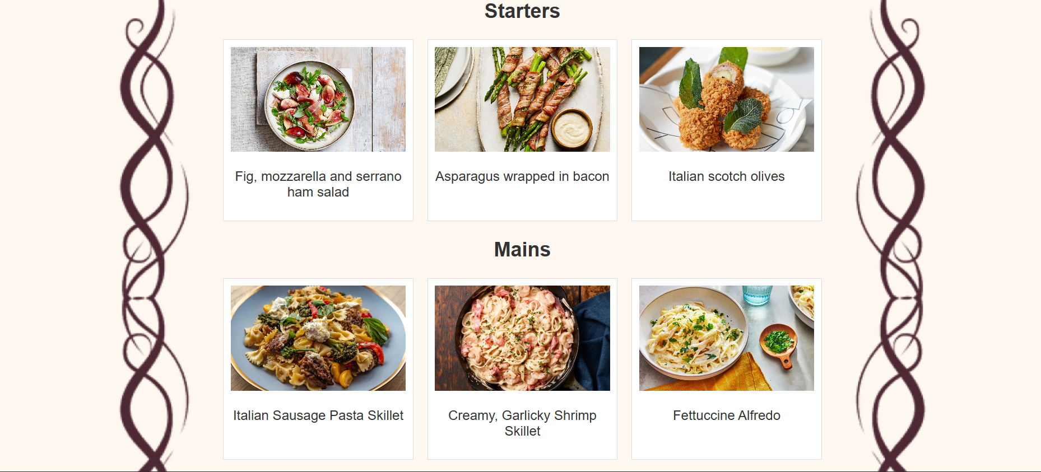

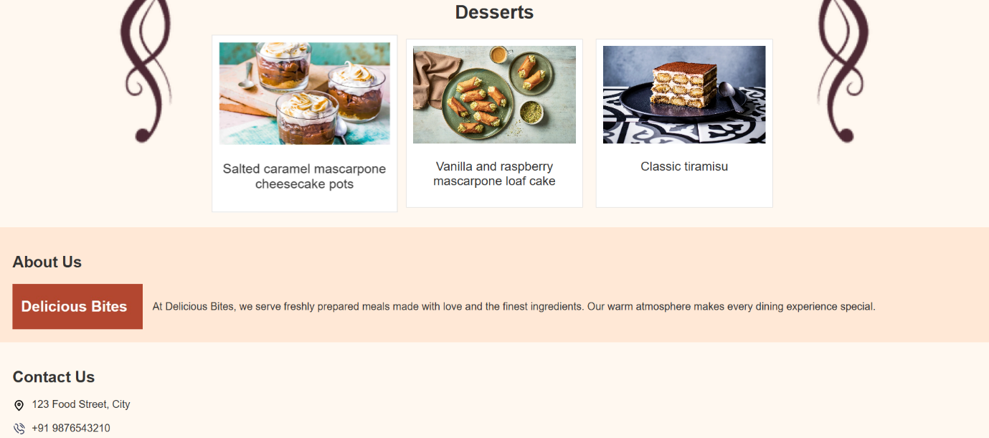



## ****13. Conclusion****

This personal diary project demonstrated how creative design can be achieved using only HTML and CSS. By combining textures, fonts, and decorative effects, the interface replicates the charm of a real notebook. The hands-on process strengthened understanding of CSS styling, layout structuring, and UI creativity without relying on JavaScript or backend technologies.